**Experiment – 10**

**Student Name: Vivek Kumar UID: 21BCS8129**

**Branch: BE-CSE(LEET) Section/Group: WM-20BCS-616/A**

**Semester: 5th Date of Performance: 9/11/2022**

**Subject Name: Machine Learning Lab Subject Code: 20CSP-317**

**1. Aim/Overview of the practical:**

Implement Association Rule Mining.

**2. Task to be done/ Which logistics used:**

Implement Association Rule mining.

**3. Steps for experiment/practical/Code:**

data = [

        ['T100',['I1','I2','I5']],

        ['T200',['I2','I4']],

        ['T300',['I2','I3']],

        ['T400',['I1','I2','I4']],

        ['T500',['I1','I3']],

        ['T600',['I2','I3']],

        ['T700',['I1','I3']],

        ['T800',['I1','I2','I3','I5']],

        ['T900',['I1','I2','I3']]

        ]

init = []

for i in data:

    for q in i[1]:

        if(q not in init):

            init.append(q)

init = sorted(init)

print(init)

sp = 0.4

s = int(sp*len(init))

s

from collections import Counter

c = Counter()

for i in init:

    for d in data:

        if(i in d[1]):

            c[i]+=1

print("C1:")

for i in c:

    print(str([i])+": "+str(c[i]))

print()

l = Counter()

for i in c:

    if(c[i] >= s):

        l[frozenset([i])]+=c[i]

print("L1:")

for i in l:

    print(str(list(i))+": "+str(l[i]))

print()

pl = l

pos = 1

for count in range (2,1000):

    nc = set()

    temp = list(l)

    for i in range(0,len(temp)):

        for j in range(i+1,len(temp)):

            t = temp[i].union(temp[j])

            if(len(t) == count):

                nc.add(temp[i].union(temp[j]))

    nc = list(nc)

    c = Counter()

    for i in nc:

        c[i] = 0

        for q in data:

            temp = set(q[1])

            if(i.issubset(temp)):

                c[i]+=1

    print("C"+str(count)+":")

    for i in c:

        print(str(list(i))+": "+str(c[i]))

    print()

    l = Counter()

    for i in c:

        if(c[i] >= s):

            l[i]+=c[i]

    print("L"+str(count)+":")

    for i in l:

        print(str(list(i))+": "+str(l[i]))

    print()

    if(len(l) == 0):

        break

    pl = l

    pos = count

print("Result: ")

print("L"+str(pos)+":")

for i in pl:

    print(str(list(i))+": "+str(pl[i]))

print()

from itertools import combinations

for l in pl:

    c = [frozenset(q) for q in combinations(l,len(l)-1)]

    mmax = 0

    for a in c:

        b = l-a

        ab = l

        sab = 0

        sa = 0

        sb = 0

        for q in data:

            temp = set(q[1])

            if(a.issubset(temp)):

                sa+=1

            if(b.issubset(temp)):

                sb+=1

            if(ab.issubset(temp)):

                sab+=1

        temp = sab/sa*100

        if(temp > mmax):

            mmax = temp

        temp = sab/sb*100

        if(temp > mmax):

            mmax = temp

        print(str(list(a))+" -> "+str(list(b))+" = "+str(sab/sa*100)+"%")

        print(str(list(b))+" -> "+str(list(a))+" = "+str(sab/sb*100)+"%")

    curr = 1

    print("choosing:", end=' ')

    for a in c:

        b = l-a

        ab = l

        sab = 0

        sa = 0

        sb = 0

        for q in data:

            temp = set(q[1])

            if(a.issubset(temp)):

                sa+=1

            if(b.issubset(temp)):

                sb+=1

            if(ab.issubset(temp)):

                sab+=1

        temp = sab/sa*100

        if(temp == mmax):

            print(curr, end = ' ')

        curr += 1

        temp = sab/sb*100

        if(temp == mmax):

            print(curr, end = ' ')

        curr += 1

    print()

    print()

**4. Result/Output/Writing Summary:**

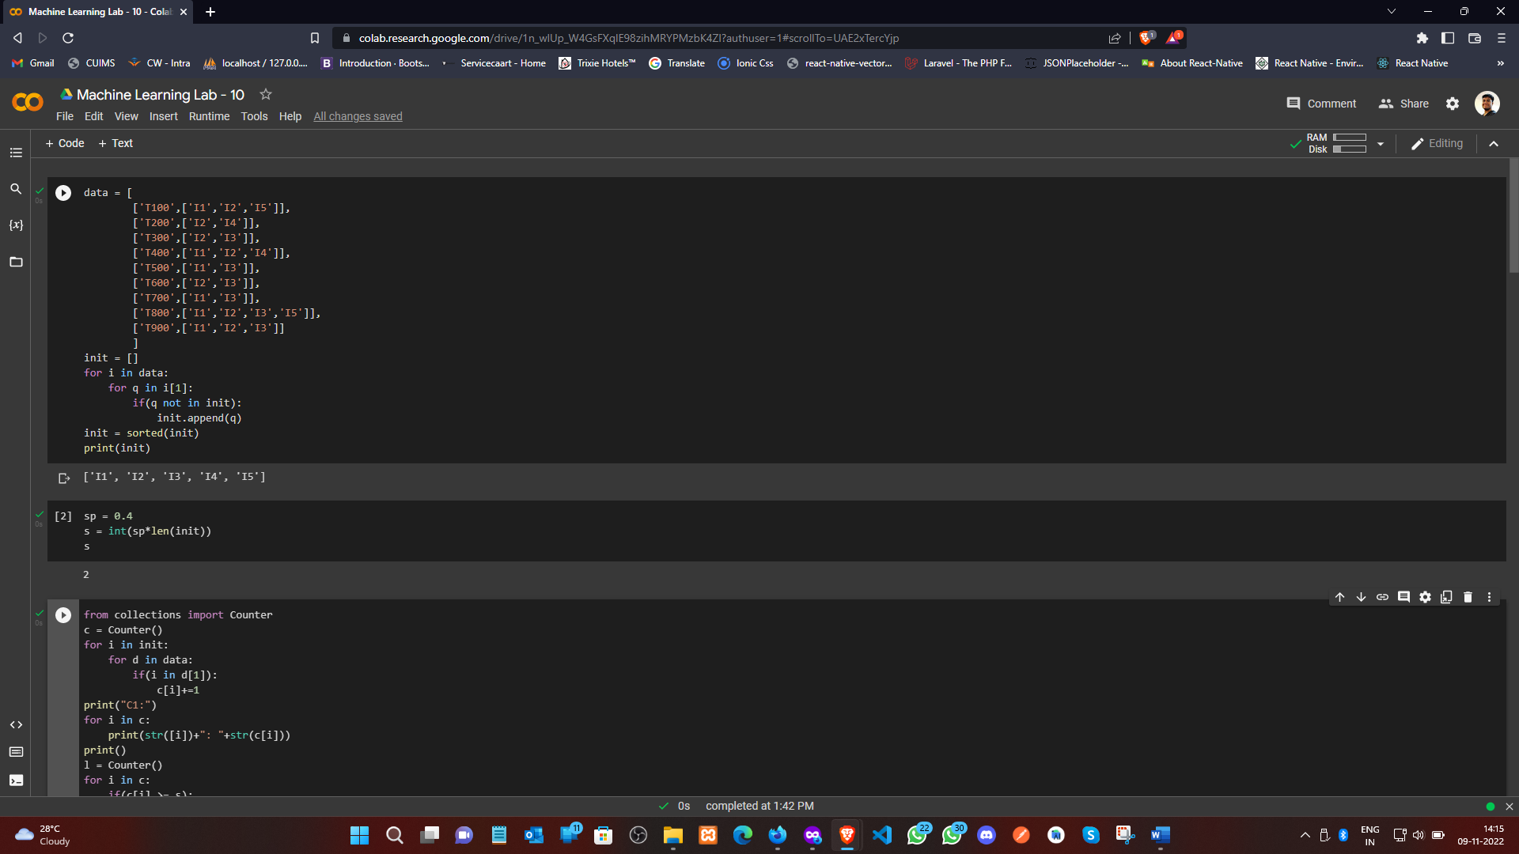

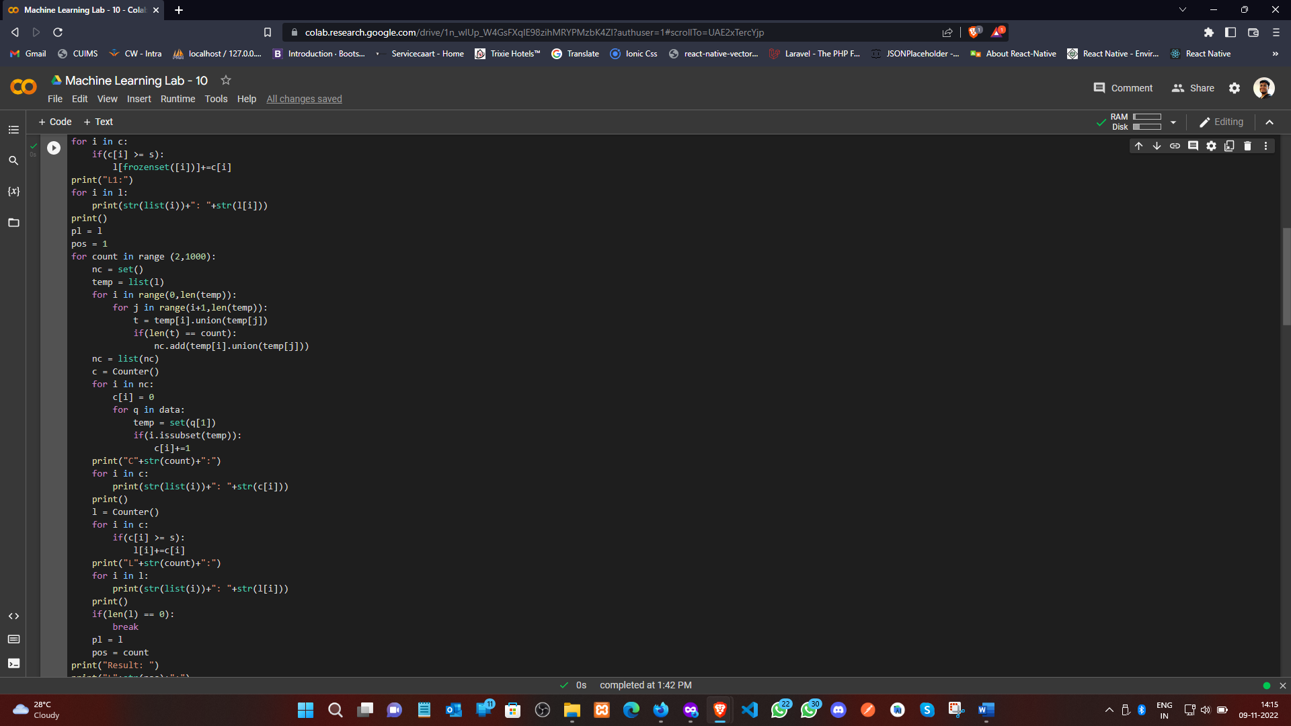

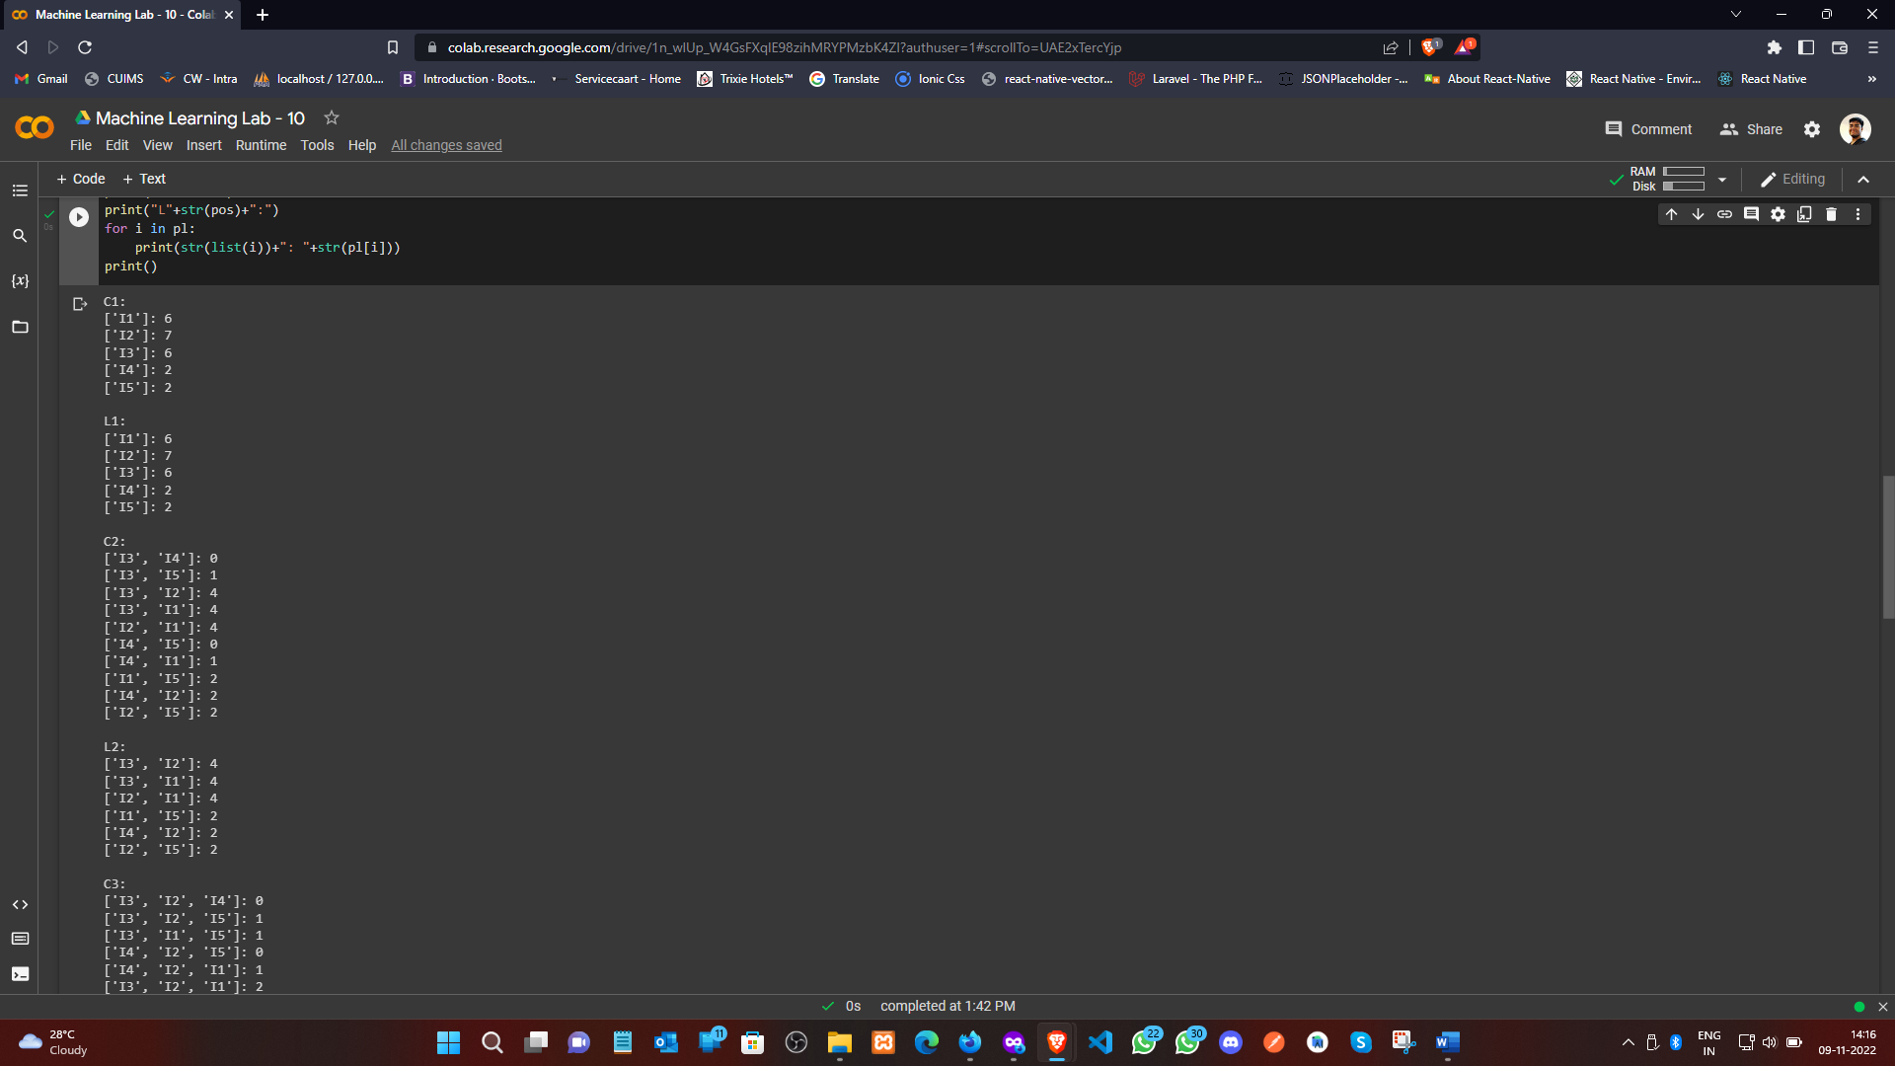

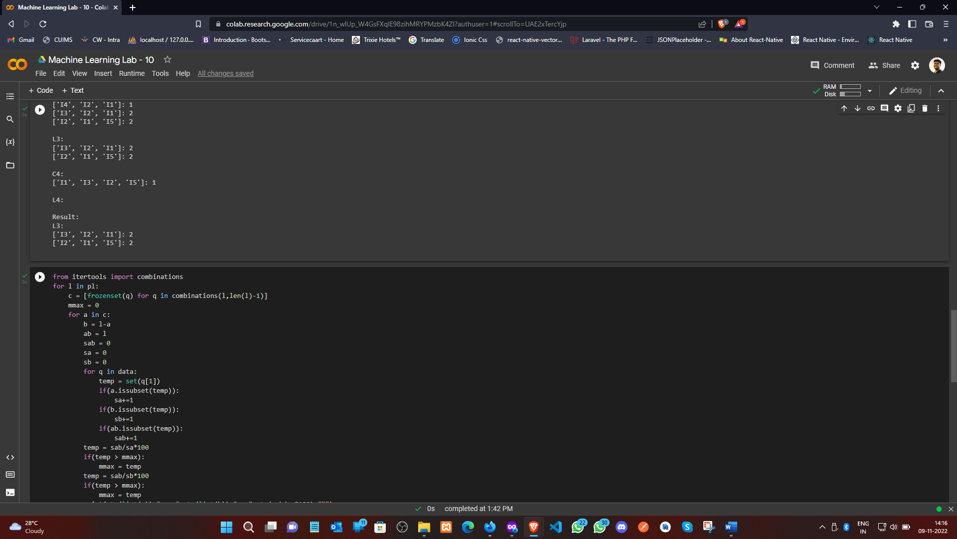

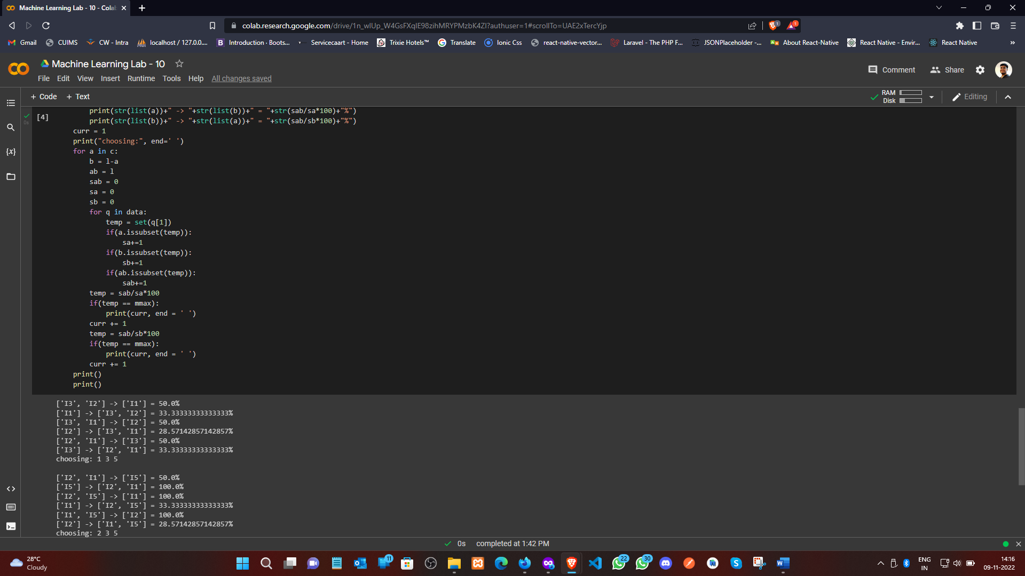

**Learning outcomes (What I have learnt):**

1. Understood the concept of PCA.
2. Learnt how to Covariance Matrix.
3. Learnt the separation of eigen value and eigen vectors from CM.
4. Plot the graph using seaborn and matplotlib.

**Evaluation Grid (To be created as per the SOP and Assessment guidelines by the faculty):**

|  |  |  |  |
| --- | --- | --- | --- |
| Sr. No. | Parameters | Marks Obtained | Maximum Marks |
| 1. |  |  |  |
| 2. |  |  |  |
| 3. |  |  |  |
|  |  |  |  |